**Set:-**

A set is an unordered , collection of datatype that is iterable , mutable and has no duplicate values.

Note:- set items are unchangeable , but you can remove items and add new items.

Note:- sets are unordered , so you cannot be sure in which order the items will appear.

**Creating a set:-**

A set is created by placing all the element inside curly bracket {}, separated by comma or by using the built-in function set().

**Syntax:-**

Set_variable ={val1,val2,….}

Example:-

**Programming tip:-**

If we add the same element multiple times in a set, they are removed because a set cannot have duplicate values.

Note:-

1. List is coverted into a set
2. Tuple is converted into a set
3. String is converted into a set

Set operations:-

**Adding items to a set:-**

We can add elements to a set by using add() method. Again as discussed there is no specific index attached to the newly added element.

Example:-

**Removing item from a set:-**

We can remove elements from a set by using discard() method. Again as discussed there is no specific index attached to the newly added elements.

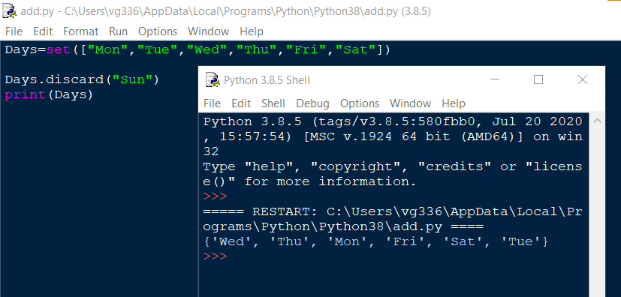

**Union of set:-**

The union operation on two sets produces a new set containing all the distinct elements from both the sets. In the below example the element “Wed” is present in both the sets.

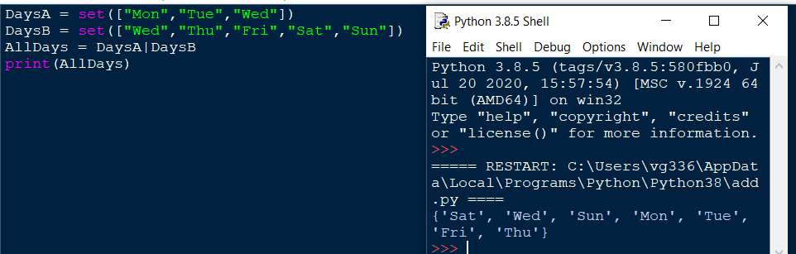

**Intersection of sets:-**

The intersection operation on two sets produces a new set containing only the common elements from both the sets. In the below example the element “Wed” is present in both the sets.

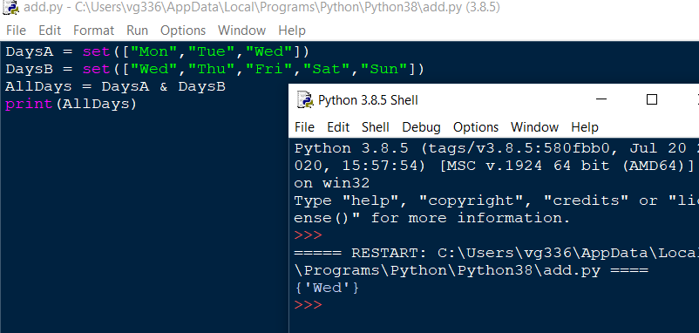

**Accessing the items in a set:-**

You cannot access items in a set by referring to an index or a key.

But you can loop through the set items using a for loop, or ask if a specified value is present in a set, by using the in keyword.

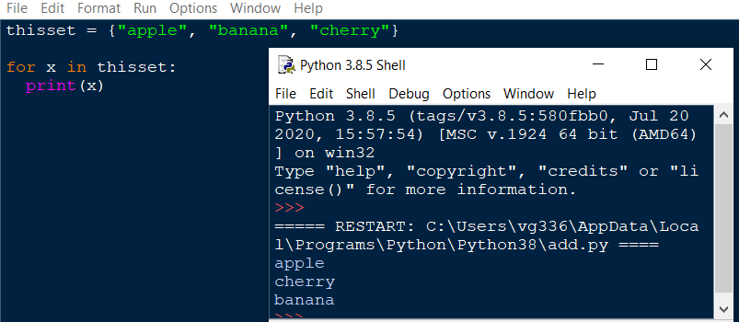

**Frozen set:-**

The frozenset() function returns an immutable frozenset object initialized with elements from the given iterable.

Frozen set is just an immutable version of a python set object. While elements of a set can be modified at any time, elements of the frozen set remain the same after creation.

Due to this, frozen sets can be used as keys in Dictionary or as elements of another set. But like sets, it is not ordered (the elements can be set at any index).

***Syntax:-***

***frozenset([iterable])***

iterable(optional):- the iterable which contains elements to initialize the frozenset with.

Iterable can be set, dictionary , tuple , etc.

**Return value from frozenset():-**

The frozenset() function returns an immutable frozenset initialized with elements from the given iterable.

If no parameters are passed, it returns an empty frozenset.

